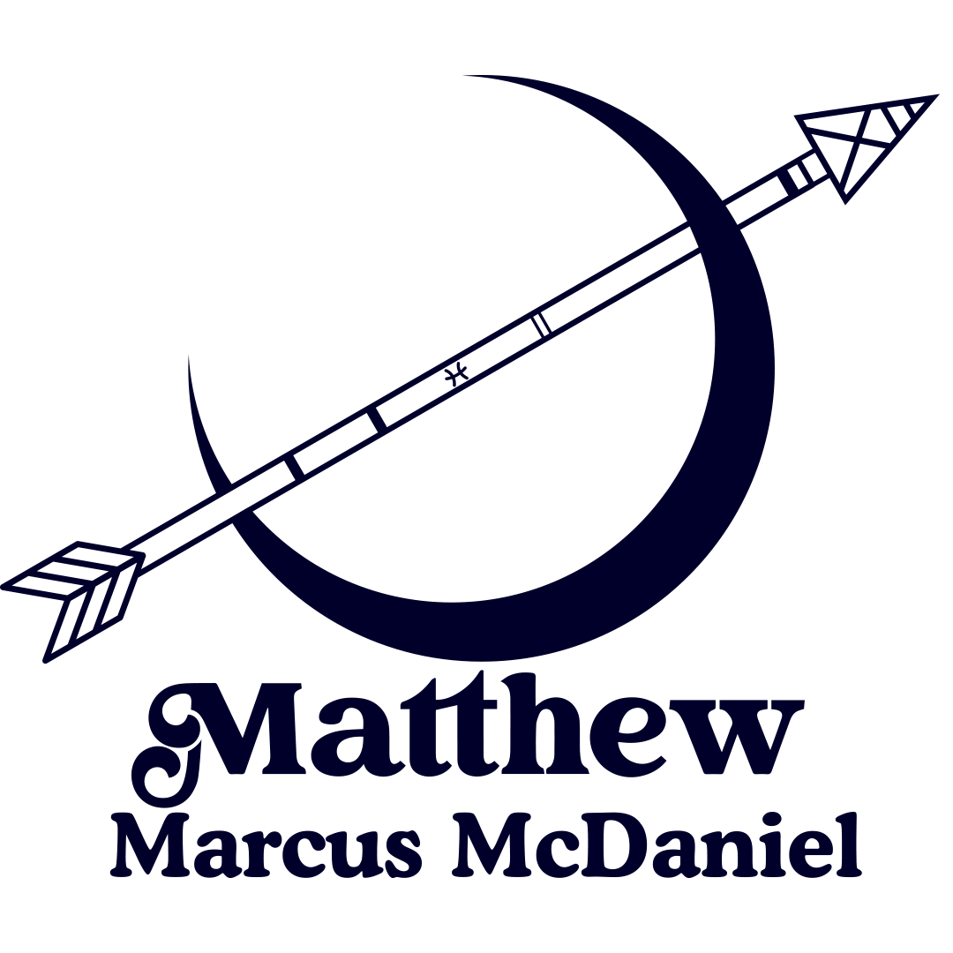 Stage Plot (Electric / Acoustic One Man Band)

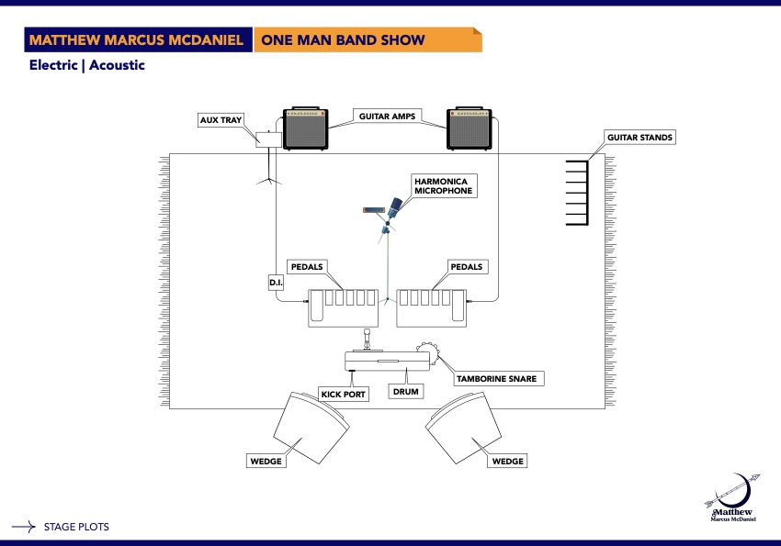

Technical Rider & Input List (One Man Band)

XLR Lines: 8 Channels
1 - vox
2 - Electric Guitar Amps
1 - Harmonica Amp
1 - DI Line
1 - Kick Drum
1 - Snare
1 - Hi Hat

Mics (Preferred):
Shure Super 55 or Beta 58
Shure 520DX Bullet Mic
(3) SM 57 or Sennheiser 609 (Amplifiers)
(1) Shure Beta 52A or Audix D6
(1) Snare Mic Shure SM 57 or Audix i5
(1) Hi-Hat Mic Shure SM81, KSM 141, or Audix ADX 51

Power:
Across the front of the stage for pedalboards, wedges & misc.
Across the back, 3 electric amps.

Front of House (FOH):
QSC, EV, JBL, Turbo Sound, 2 Mains, 2 Subs
Digital Board with Bluetooth & External Recording Capabilities

Monitors:
(2) Wedges – QSC K10.2 or K12.2 or EV 1x12 or Omega Pro Audio Stage Monitors

Monitor Mixes: Stereo monitors, balanced house mix in monitors
Vocal Effects - Reverb and Delay
Kick, Snare, Hi-Hat - Slight Reverb depending on the room
Matthew Provides:
Vocal Microphone
DI for Acoustics (*Phantom Power Required*)
Stage Cables & Mic Stand
Able to provide Stage Monitors

Lighting: Whitewash Outs, Color Mixes, Blue LED Washes & Fades, Fog Machine

Playout Songs:
The World is Mine- Samm Henshaw, The Force- Lettuce, Runnin’- David Dallas

***Matthew is able to provide all necessary production***

Stage Plot (Acoustic One Man Band)

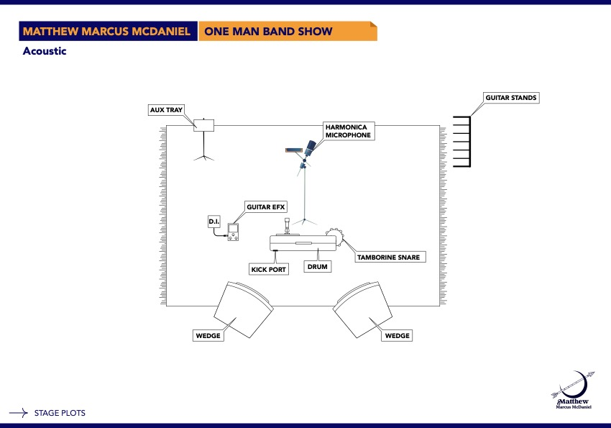

Technical Rider & Input List (Acoustic One Man Band)

XLR Lines: 6 Channels
1 - vox
1 - Harmonica Amp
1 - DI Line
1 - Kick Drum
1 - Snare
1 - Hi Hat

Mics (Preferred):
Shure Super 55 or Beta 58
Shure 520DX Bullet Mic
(3) SM 57 or Sennheiser 609 (Amplifier)
(1) Shure Beta 52A or Audix D6
(1) Snare Mic Shure SM 57 or Audix i5
(1) Hi-Hat Mic Shure SM81, KSM 141, or Audix ADX 51

Power:
Across the front of the stage for pedalboards, wedges & misc.
Across the back, 1 electric amps.

Front of House (FOH):
QSC, EV, JBL, Turbo Sound 2 Mains, 2 Subs
Digital Board with Bluetooth & External Recording Capabilities

Monitors:
(2) Wedges – QSC K10.2 or K12.2 or EV 1x12 or Omega Pro Audio Stage Monitors

Monitor Mixes: Stereo monitors, balanced house mix in monitors.
Vocal Effects - Reverb and Delay
Kick, Snare, Hi-Hat - Slight Reverb depending on the room.
Matthew Provides:
Vocal Microphone
DI for Acoustics (*Phantom Power Required*)
Stage Cables & Mic Stand
Able to provide Stage Monitors

Lighting: Whitewash Outs, Color Mixes, Blue LED Washes & Fades, Fog Machine

Playout Songs:
The World is Mine- Samm Henshaw, The Force- Lettuce, Runnin’- David Dallas

***Matthew is able to provide all necessary production***

Technical Rider & Input List (ACOUSTIC SHOW)

XLR Lines: 2 Channels
1 - vox
1 - DI Line

Mics (Preferred):
Shure Super 55 or Beta 58

Power:
Across the front of the stage for pedalboards, wedges & misc.

Front of House (FOH):
QSC, EV, JBL, Turbo Sound, 2 Mains, 2 Subs
Digital Board with Bluetooth & External Recording Capabilities

Monitors:
(2) Wedges – QSC K10.2 or K12.2 or EV 1x12 or Omega Pro Audio Stage Monitors

Monitor Mixes: Stereo monitors, balanced house mix in monitors
Vocal Effects - Reverb and Delay

Matthew Provides:
Vocal Microphone
DI for Acoustics (*Phantom Power Required*)
Stage Cables & Mic Stand
Able to provide Stage Monitors

Lighting: Whitewash Outs, Color Mixes, Blue LED Washes & Fades

Playout Songs:
Like a Rolling Stone- Bob Dylan
All I See is You- Shane Smith & the Saints
Come on Up to the House- Tom Waits

***Matthew is able to provide all necessary production***

